Dakota Cavanaugh
MUSIC 513
Spring 2018
Teaching Techniques in Jazz

Teaching Jazz Improv: (20 points) Building upon what you understand in teaching swing and improvisation, design a short teaching episode that can be used in teaching harmonic improvisation to a young jazz ensemble. You will have 10 minutes to teach a lesson that includes:

- Warm-up Strategy (>1 minute)
  - Long tones or scales (variations of modes or blues scale
- Addressing Style (>1 minute)
  - Swing
- Teach a bass line (2 minutes)
- Teach a melody (2 minutes)
- Improvise! (4 minutes)
- Reflection

 | 1 Points | 2 Points | 3 Points
Objective | Objective is missing more than one of the required parts and has no intent with respect to student learning. | Objective is missing one of the three parts and is unclear as to intent of student learning. | Objective contains all three parts and is clear as to educational value.
Assessment | Assessment is simply a description of the process and not clear as to its alignment with the objective or how feedback will be delivered. | Assessment is aligned with the objective but lacks in clarity or measurement. Detailed feedback is not apparent from the current design. | Assessment is aligned with the objective and clearly and objectively measures student learning providing detailed feedback for the learner.
Sequence | Sequence is vague and/or not provided in depth. More work is needed to show learner development. | Sequence is missing 1-2 steps that provide opportunities for misunderstandings on part of the learners. | Sequence is clear. Learning is scaffolded for the learner to arrive at a new understanding.
Concept | Concept is not included or clear in the lesson plan. | Concept is defined, but clarity with connection with the content is difficult to measure. | Concept is clear from the lesson design and clearly described in the plan.
Delivery | No lesson presented. | Lesson goes over time or is unclear in focus. | Lesson meets all criteria regarding time and content.
 | 1 Points | 3 Points | 5 Points
Reflection | Reflection not completed. | Reflection is complete, but limited reach beyond this experience. | Reflection demonstrates insightful though about the episode.
Total:________________

All TE lesson plans should be submitted with the formatting below and will be assessed using the following rubric. Each strategy must be creative, developmentally appropriate, conceptually appropriate, use proper sequence, and lead to a deeper understanding of a musical concept.

Teaching Improvisation

Name: Dakota Cavanaugh

Lesson Objective (what do you want the students to learn and be able to demonstrate?)
- Given a musical context and melody, students will be able to improvise the harmonic progression of Twinkle Twinkle Little Star on their instruments with fewer than 3 mistakes in chord tones and utilize three types of non-harmonic tones.

Prior Knowledge & Skills Expectations (what the students must already know and are able to do):
- Students know and can play their concert Bb major scale
- Students can read basic chord nomenclature (Bb, Eb⁷, etc.)
- Students know and can play the basics of jazz style (short articulations stopped with the tongue, swing, emphasis on 2 and 4, etc.
Musical Concepts Addressed in the Lesson:
- MU:Cr1.1.E.8a Compose and improvise ideas for melodies and rhythmic passages based on characteristic(s) of music or text(s) studied in rehearsal.
- MU:Pr6.1.E.5b Demonstrate an awareness of the context of the music through prepared and improvised performances.

Must Include: Detailed procedures of Instructional Strategy and Assessment for successful achievement of goal

Opening: Warm up with scales -> concert Bb major scale in half notes, then quarter notes, then eighth notes (swung) tonguing the off beats (twinkle twinkle is being played in Bb major so warming up with Bb scales makes sense).
Style warm-up: On a concert F, the teacher will model a 4 beat rhythmic/articulation pattern and the students will repeat it. Repeat 8-10 times with different variations (off beat tongued eighth notes, short/fat quarter notes, etc.).

Materials of Instruction:
- Instrument for modeling
- Chalk and chalkboard for writing chords and rhythms
- Twinkle Twinkle Arrangement

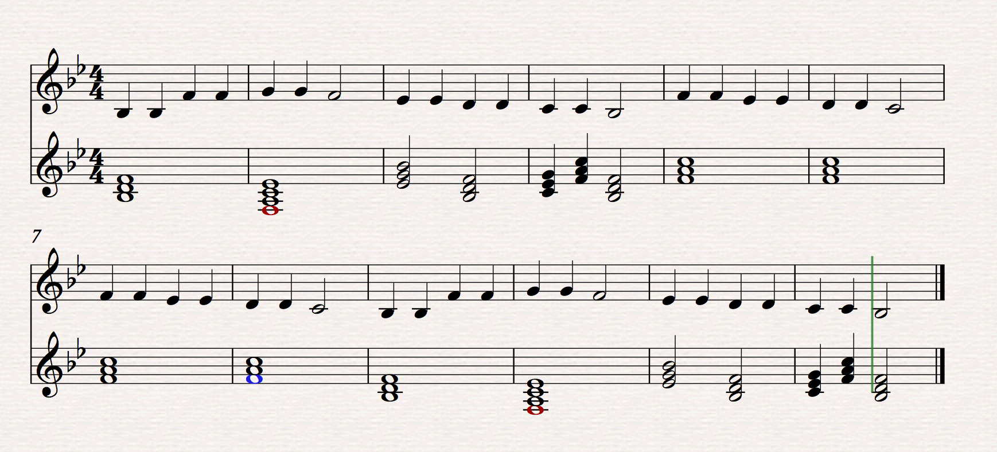

Sequence:
- Teach the melody to twinkle twinkle, via music given to students.
- Perform melody
- Teach Bass line (play whole notes for the tonic note of each chord)
- Perform bass line
- Split class in half, have each half play either bass line or melody.
- Switch and play with two parts again.
- Teach accompaniment part
  - Pick any note in each chord, and play the following rhythm:
    - Quarter note, Quarter note, Quarter note, Quarter Rest|Dotted Quarter note, eighth note, half rest.
- Divide the room in thirds, and play twinkle with melody, accompaniment, and bass.
- Switch parts 2 times so that all students perform all 3 lines.
- Play twinkle, with teacher improvising a solo over the chorus.
- Teacher plays chords on piano, and allow all students to attempt improvisation at the same time.
- Repeat, but limit note choices to chord tones (as shown in music)
- Add notes in between (passing tones)
- Divide the room 4 groups, 1 for each part of the song, and 1 group to improvise.
- Using the Bb major scale, students will improvise over the form of twinkle in small groups.
- Switch until all four groups have improvised.
- Perform tune with arrangement and melody played first, then comp chords on piano and allow students to improvise in pairs as the last activity, followed by the head out.

Assessment:
Teacher will assess students’ improvisation via the final “pairs improv” by listening for chord tones, and correct usage of non-chord tones.
Closing: Play twinkle with everyone on their favorite part, then have everyone improv at the same time (mass chaos soloing) and challenge students to listen to ideas from their classmates and try to respond somehow. (Slightly scratching into call and response/ learning to form licks together into phrases)

EDSEC 200 Introduction to Teaching
Field Teaching Reflection
Name
Dakota Cavanaugh

Type your evaluation of each of the areas addressed below. (each box will expand as you type in it.) Please, type your response in the spaces provided on this form and submit it in Digital Drop Box prior to the next class session after you taught.

Prior To Teaching

What were your greatest concerns as you prepared to present your lesson?
I was worried about whether or not letting the students pick chord tones to set with the rhythm for the accompaniment part was a good idea.

How did you attempt to address these concerns?
I asked some classmates if they thought it would work, and practiced explaining the sequence to my dog (rehearsed how to explain/ teach concepts by rote)

As you wrote you plan, how did you make use of what you know about sequential instruction, active learning, and teaching creatively?
You always want to scaffold and move progressively from where the students feel the most comfortable to a place outside their comfort zone for the purpose of learning. So, I attempted to structure my lesson in a way that was conducive to building confidence on the new topic (improvisation). I started with the melody to a song that everyone should be comfortable playing. Then introduced mildly abstract, but very attainable background/arranged parts. Then the students improv as a whole class (so that nervousness is limited and they can try out ideas in an environment where there classmates aren’t focused on what they are playing). Progressing down to smaller groups allows the students to gain confidence in the process and by the time they are improvising in small groups/pairs, they have enough confidence to continue experimenting ideas with minimal nervousness about failing or doing poorly.

Teaching Delivery

What were you thinking about the most when you were teaching?
I was mostly focused on how to say things in a concise, but still explicitly clear manner. My knowledge for jazz is pretty steady, so applying teaching concepts within jazz was the main focus for my own success as the teacher.

How did you effectively use your delivery skills (voice, body, eye contact, use of space)?
I always spoke with a confident/commandeering voice, and attempted to be very straight-forward so as to be easy to understand. I shifted throughout the room to listen to individuals play, and made eye contact with students to (hopefully) encourage them when they had good ideas.

What would you want to change in your delivery skills for next time you teach?
I want to stutter less. Sometimes it just takes me too long to come up with the right word or phrase to describe a concept. Fluidity in teaching and explanations without being verbose is my main goal for improvement.

Did you or did you not appear confident as you taught your lesson? What lead you to that impression?
I believe that I appeared confident while teaching because I demonstrated knowledge of the subject through modeling, and the students stayed engaged and on track with the lesson (which won’t happen if they don’t trust the teacher’s skill/knowledge set/confidence).

Teaching Content

What was most effective about the sequence in which you taught your lesson?
The most effective part of my sequence was the preparation/warm up. The articulation exercises flowed into my lesson nicely and was very apparent in the students playing! The transfer of concepts into the actual improvisation and playing of twinkle twinkle was great.

How would you change this sequence the next time you teach?
I would add a backtrack for the chord accompaniment, because this would allow me to do call and response exercises while working on improv.

Were your models, both vocally and instrumentally, accurate? What could you do to make these more effective?
My modeling was mostly good. I played with good tone, style, etc. My timing for modeling could use some improvement. When does something need to be modeled vs. when can something be explained without a physical demonstration? Which is more beneficial in different kinds of situations? Being intentional with modeling is a goal of mine for future lessons.

Reflections

I think I understand how, but need to practice more on…
I think I understand how to teach jazz concepts well, but I need more practice on wording my delivery in a way that is conducive to students understanding. I tend to talk too much sometimes or talk over the students’ heads. Remembering that you can’t talk to high schoolers the same way you would talk to collegiate colleagues is a huge deal.

I just don’t understand…
I don’t understand how to fully/correctly utilize non jazz tunes for teaching improv. Adding swing eighths or changing articulation isn’t usually enough on its own, and will just make the tune sound corny/ not stylistically appropriate. Is there an important reason why non-jazz tunes are also used in teaching improvisation? Also, the chordal structure is different and blues patterns don’t always work on a standard, major keyed piece. Integrating these ideas (if necessary) is definitely a struggle for me.

The following is my plan to work on the areas I have noted above…
I will work to improve on using concise statements while teaching. Short feedback is a good thing, give the kids as much opportunity to play as possible. Also, I will work to come up with a few phrases or transitions that can be used as fillers that way awkward space doesn’t happen as often. Having a “word bank” for things to say may help when I can’t think of a specific term or phrase on the spot.

