Elementary Unit
Dakota Cavanaugh
11/26/18

Table of Contents

Unit Introduction 3
Unit Outline 3-5
Lesson Plans
Lesson 1 6-10
Lesson 2 11-13
Lesson 3 13-15
Lesson 4 16-18 Lesson 5 19-20
Lesson 6 20-21
Lesson 7 22-23
Lesson 8 23-24
Lesson 9 24-25
Lesson 10 25-26
Song one: Great Big House in New Orleans 27
Song two: Here Comes a Bluebird 28
Song three: Knock the Cymbals 29
Song four: Star Light, Star Bright 30
Song five: Wall Flowers 31
Song six: Al Citron 32

Unit Introduction

The focus of this unit is teaching G and F pentatonic. According to the USD 383 Manhattan District Scope and Sequences, students will already be proficient in various quarter note and eighth notes rhythms and will have already learned and be proficient with solfege syllables such as do, re, mi, sol, and, la. Students will have performed different pieces in both F and G. The goal of this unit is to help students be able to comfortable with both F and G pentatonic and be able to understand the difference between the two for the sake of introducing the concept of movable do.
The target grade for this unit is 2nd grade. The songs, activities, and games that make up this unit plan are all appropriate for children at this grade level. Students will primarily focus on learning F and G pentatonic, but they will continue to develop other musical knowledge, skills, and concepts that will be experienced through the chosen activities and songs. Knowledge, skills, and concepts include: analyzing text, movement, timbre, rhythm, varying melodies, improvisation, and composition. Students will also work with instruments such as xylophones, rhythm sticks, and various body percussion.
This unit will feature various cross curricular connections as well. Connections include: different musical genres, dance, creating art, writing skills, and the historical and cultural backgrounds of the songs. Historical and cultural backgrounds will be explored for all songs present in this lesson. We will explore traditions, languages, and music from varying cultures and countries. Each song that students will cover will be from multiple different cultures and students will learn about dances, traditional song from England, and learn about Mexican children’s songs. Exposing students to historical/cultural listening examples and performances will help students understand and explain how music can be used to communicate in their own culture.

Pre-Assessment:
- The students will sing through Great Big House in New Orleans and Star Light, Star Bright with hand signs.

Students play F quarter notes while playing Star Light, Star Bright

T: Did you notice anything out of the ordinary?
Use the visual of steps to help connect concepts:

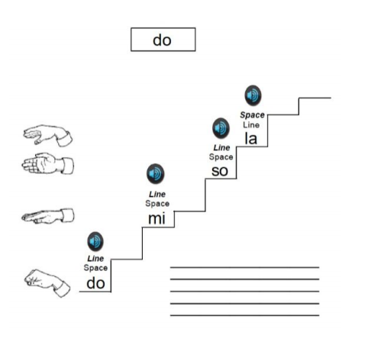

T: Why do you think Do sounds different in the two songs?

Use standard notation:

T: The reason these two songs are different is because they are in different keys. Keys are similar to languages, even though they can sound different, they can mean exactly the same thing.

Questions over the concept:
So why do you think that we say Do all the time if it changes notes?
Do you think that Do can change from song to song?

Switch keys of the songs (transpose) and have students sing again.

Post-Assessment:
- Students will be put into groups and be asked to create an 8 measure melody on their own in either F or G pentatonic. Then, they will transpose it to the other key (see lesson 10). The following assessment will be given for the 10th lesson:
- Students compose a new melody in G pentatonic:
  - Procedure as in Lesson 10
  - T will assess and provide a score
    - 1 – Didn’t try
    - 2 – Attempted, but not able
    - 3 – Able
- Students are asked to change the key of the piece to F pentatonic
  - Procedures in Lesson 10
  - T will assess using the same scores in step 1.
- Students will be asked to improvise a melody in the F pentatonic
  - Procedures as are in lesson 9
  - T will assess using the same scores as in steps 1 and 2

Lesson 1

Objectives: Students will sing “Great Big House in New Orleans” with accurate rhythm (2/4 meter, quarter notes and eighth notes) and pitch (F pentatonic)

Students will create an accompaniment for “Great Big House in New Orleans” in 2/4 time.

Students will perform melodic improvisations within 8 measures of 2/4 time, given pitches of a F major pentatonic scale (FGA CD).

Standards Being Addressed:

Improvisation:

MU:Cr1.1.2b Generate musical patterns and ideas within the context of a given tonality (such as major and minor) and meter (such as duple and triple).

Song/Arrangement/BP:

MU:Pr5.1.2b Rehearse, identify and apply strategies to address interpretive, performance, and technical challenges of music.

MU:Pr6.1.2a Perform music for a specific purpose with expression and technical accuracy.

Materials of Instruction: From “Sail Away” #19, transposed to F.
- Xylophones
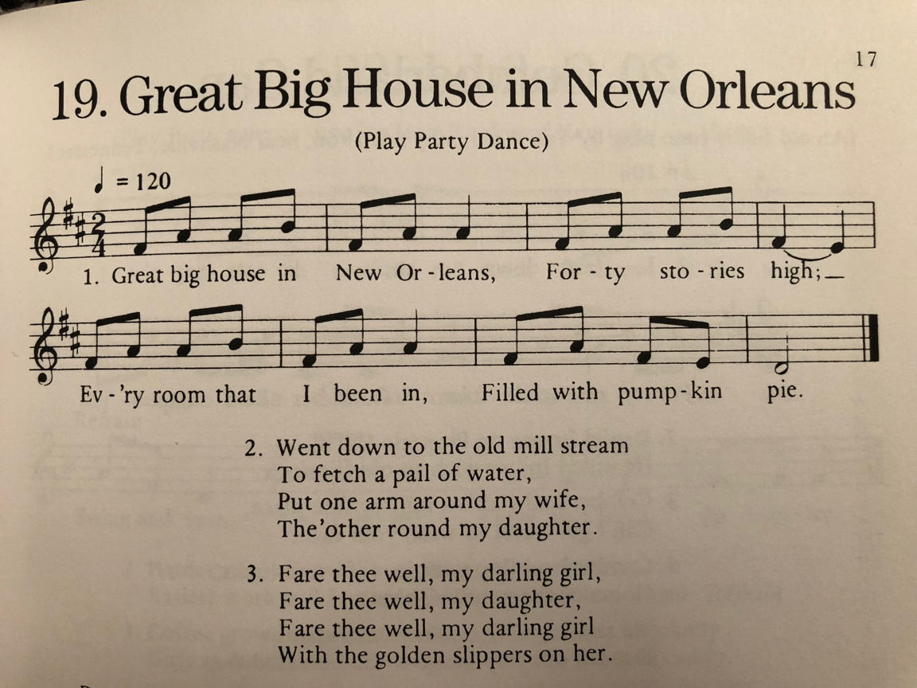

Lesson Sequence (lessons may have more or less activities as appropriate):

Entry Activity/Transition: “Hello 2nd Graders! Everyone come stand in a circle.”
a. “Everyone watch me, and do what I do.” (T does a stomp/clap body percussion in 2/4 with stomps on beat one and clap on beat two. Stay with the tempo)
b. Teacher will wait until most/all students have joined in, then move to a xylophone. T will then add in a half note F and C ostinato.
c. “Now, you guys keep going with the stomps and claps, and I’m going to sing you a song!”
d. T sings “Great Big House in New Orleans”
e. T asks Ss: Where is the great big house? How many stories high is it? What are all of the rooms filled with? Sing again if needed as a reminder.
f. “Thank you for helping me play my song 2nd graders, and now I want to teach it to you all because it’s one of my absolute favorites!

Activity #1: Students will sing “Great Big House in New Orleans” with accurate rhythm (2/4 meter, quarter notes and eighth notes) and pitch (F pentatonic)

1.Ss pat the steady beat while T plays the xylophone and sings the song again.

2. Echo the 2-bar phrases
a. T sings on starting note (“This is our starting note.”) and gestures to self: Great big house in New Orleans (T gestures to Ss and Ss echo).

b. T gestures to self: “Forty stories high” (Gesture to Ss and they echo)
c. T gestures to self: “Every room that I been in” (Gesture for Ss to echo)
d. T gestures to self: “Filled with pumpkin pie” (Gesture for Ss to echo)

3. Echo the longer phrases
a. T reminds students of starting note (“Hums note, “Everyone hum our starting note”). T gestures to self: “Great big house in New Orleans, Forty Stories High” (Gesture to Ss and Ss echo)

b. T gestures to self: “Every room that I been in, filled with pumpkin pie.” (Gestures to Ss to echo)

c. repeat phrases as needed for comprehension.

4. Audiate the whole song: “Now let’s sing the song in our heads with our “magic lips.” T hums the starting pitch and counts off, but T and Ss sing whole song using only “magic lips.”

5. T and Ss sing whole song
a. “Were there any parts you had trouble remembering?”
b. Create movements to help Ss remember words.

Assessment: Can all students sing the whole song with accurate pitch and rhythm? If not, review those specific parts as needed.
Transition: “Hey, let’s throw in some xylophones to go along with our song!”

Activity #2: Students will create an accompaniment with xylophones in 2/4 meter to “Great Big House in New Orleans.”

1. Students will partner off with 1 and 2 number system.
2. Teach the 1’s the F and C half note ostinato pattern played by the teacher earlier in the lesson.
3. Teacher plays ostinato with 1’s, and 2 students sing the melody.
4. Teach the melody of the song to the 2’s.
5. Teacher sings the melody, 2’s play the melody on xylophone, 1’s play the half note ostinato.
6. Students switch parts so that each student gets to play both parts, and repeat the above 2-5.
7. Perform song again with students on switched parts.
8. Review difficult sections as needed.

Assessment: Can all students play the accompaniment on xylophone in 2/4 with steady beat? Teacher will listen and evaluate.

Transition: “Let’s get one more play through of that, but this time I want everyone to play the part that the 1’s learned very first (half note ostinato). While students play, the teacher improvises. After the song finishes, the teacher asks “What happened that was different that time around?” (Start of Improvisation)

Activity #3: Students will improvise in C pentatonic pitch set in 2/4 time in the phrase
length of “Great Big House in New Orleans.”

1. “What happened that was different that time around?” (Played something different.) “Did I play something we learned or something new?” (Something new, made-up.)

2. “You got it! Now before we all give a try, tell me what’s wrong with this made-up part.”

3. Students play ostinato; Teacher plays a poor improvisation example.

4. “What was wrong with that?” (Played too loud, weird notes, too fast)

5. “Great! So when we are making up our own parts, let’s play softly enough that we can all hear ourselves, and also play with a steady beat. And, just to make sure we get the right notes, we need to take off a few keys.” Have students remove e and b keys. And just so our own parts sound nice, let’s all try to start and end on a F.

6. “Awesome! So let’s try improvising with everyone. We’ll play the song 1 time, and the half notes will keep going the second time around. While that is happening, 1’s will improvise. Then we play the song again, and the second time around, the 2’s will improvise. Lastly, play the song a last time with everyone to round it out.

Assessment: Can all students improvise in the phrase length (8 bars) and meter (2/4)? Can some students modify their improvisation to end on C (tonic)?

Closure: Everyone plays the half note ostinato, and each person takes a turn improvising individually for the teacher. “Did you all have a good time making up your own music today? It’s called improvisation. We’ll keep doing it so get pumped for next time!”

Lesson 2

Standards Being Addressed:
Improvisation:
MU:Cr1.1.3b Generate musical ideas (such as rhythms and melodies) within a given tonality and/or meter.
Performing:
MU:Pr4.1.2a Demonstrate and explain personal interest in, knowledge about, and purpose of varied musical selections.

Materials: Here Comes a Bluebird
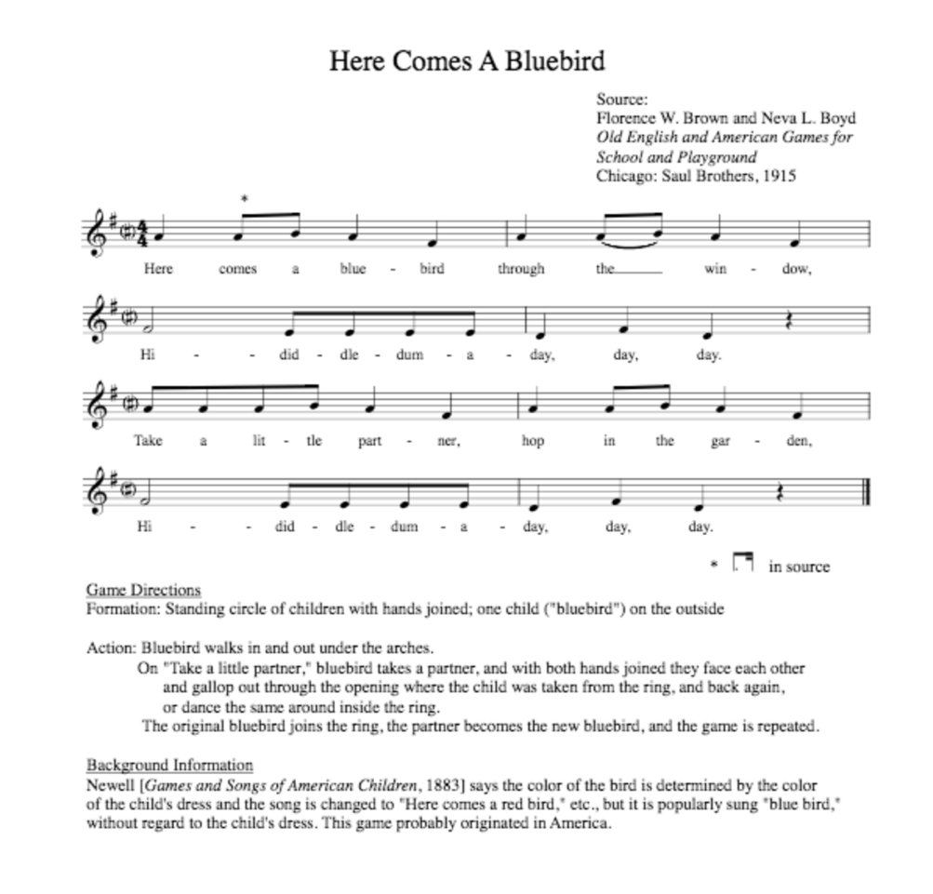

Objective: Students will be able to sing “Here Comes a Bluebird” with accurate rhythm (4/4 meter, quarter and eighth notes, and quarter rests) and pitch (G pentatonic).

Students will create body movement to go along with “Here comes a Bluebird”.

Entry Activity/Transition
- “Good morning 2nd grade! Today we are going to learn another fun song but instead of adding musical instruments, we are going to add body movement. Let's start with the melody!
Activity #1
- “This first time, just listen to how the song sounds” T sings “Here Comes a Bluebird”.
- Hum melody
  - T sings starting note (“This is our starting note”).
  - Ss hum the melody while T sings
- Add words
  - Put lyrics up on the board so the students can read them and sing
  - All sing “Here Comes a Bluebird”.
Assessment: Can all students sing the whole song with accurate pitch and rhythm? Work on parts that students are struggling with.

Transition/Activity #2
- “I’m going to sing this song for you again but this time instead of listening to the melody, focus on what the words are talking about.”
- T sings “Here Comes a Bluebird”.
- “What is the animal this song is singing about?” (A bluebird).
- “Everyone stand up and move your body to the music, freestyle!”
- T sings “Here Comes a Bluebird” while students move.
- “Great moves! Bluebirds could fly more places than just in through a window. What are some other places the blue bird could go?” Class brainstorms 4 ideas, teacher writes them on the board.
- Class comes up with movements that go with each new place listed.
- “This time while we sing, we are going to sing the bluebird going here instead. As we sing each place, do the new move you came up with.”
- Sing through the variations that the class created while doing the actions they created.

Assessment: Can all students create their own lyrics and movements to sing and do throughout the whole song? Teacher will watch and listen to evaluate.

Lesson 3

Standards Being Addressed:
Improvisation:
MU:Cr1.1.3b Generate musical ideas (such as rhythms and melodies) within a given tonality and/or meter.
Performing:
MU:Pr4.1.2a Demonstrate and explain personal interest in, knowledge about, and purpose of varied musical selections.
Materials: “Knock the Cymbals”
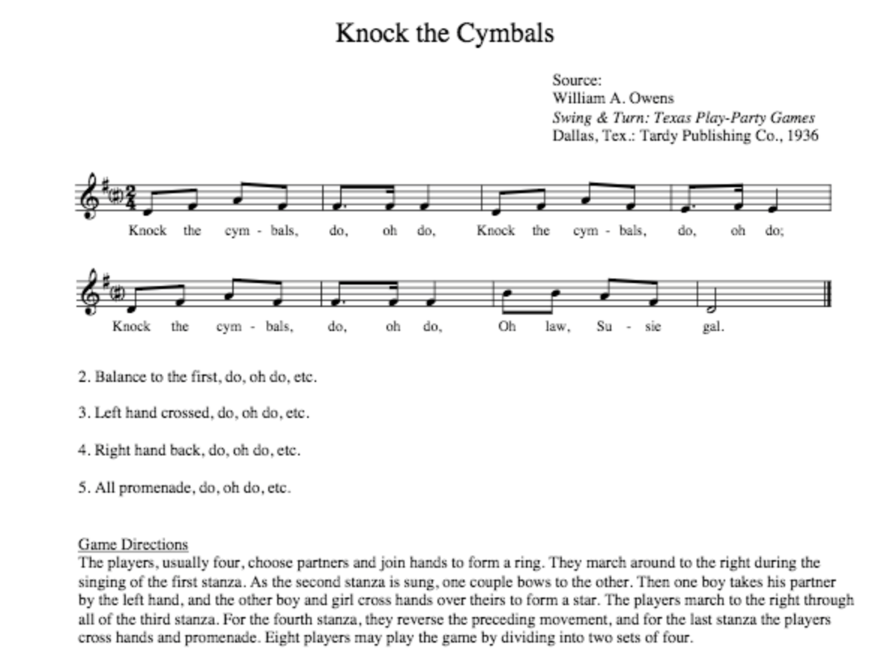

Objectives: Students will be able to sing “Knock the Cymbals” with accurate rhythm (2/4 meter, dotted eighths, sixteenth, quarter, and half notes) and pitch (F pentatonic).

Students will be able to create body percussion to go along with “Knock the Cymbals”.

Entry Activity/Transition
- “Good morning 2nd grade! Today we are going to work on a new song with intentional body percussion. Let's get going!”

Activity #1
- Echo the 2-bar phrases
- Echo the longer phrases
- Repeat phrases as needed for comprehension.
- Audiate the whole song: “Now let’s sing the song in our heads with our “magic lips.” T hums the starting pitch and counts off, but T and Ss sing whole song using only “magic lips.”
- T and Ss sing whole song
a. “Were there any parts you had trouble remembering?”

Assessment: Can all students sing the whole song with accurate pitch and rhythm? If not, review those specific parts as needed.
Transition: “Hey, let’s throw in some body percussion to go along with our song!”

Activity #2
- Have students pat their legs on the big beats on measures the odd measures.
- Have students clap - snap - pat for measures 2,4, and 6.
- Have students clap for final measure.
- Practice until students feel comfortable singing and doing body percussion.

Assessment: Can students successfully sing the song while doing body percussion?

Lesson 4
Materials: Great Big House in New Orleans

Objective: Teach F and G Pentatonic Scales, and students will see notation of movable do.

Introduction:
T: Hey friends! Today we’re going to do some more work with a song that we learned a few class periods ago. Raise your hand if you remember “Great Big House in New Orleans”.

Ss: *Raise hand as appropriate*

T: Who can remind me-
How tall was the house?
What was every room filled with?

Ss: Respond- 40 stories and pumpkin pie

T: Great memories! Then let’s go ahead and get started with today’s activities.
Activity 1: Students Review Melody in F
T: Can you all pat a steady beat on your laps with me? *start patting quarter note pulse*

Ss join in

T: Now I’m going to add some xylophone in the background, keep that pulse going. *Teacher plays F and C drones*

T: Let’s sing through Great Big House in New Orleans and see how well we remember it.

Ss: Sing through the tune in F and review portions as needed.

Activity 2: Percussion
*Students remove bars from the xylophones so that only the notes of the F pentatonic scale remain (F, G, A, C, D, F)
*The Teacher will put colored stickers on the correct bars before class such as Red (F), Blue (G), Green (A), Orange (C), Purple (D)

T: Okay, everyone watch me first to hear what we’ll be playing.
T: Play through the entire melody, then break it up into 2 measure chunks. Teach by rote, review as needed.
Ss: Put together into 2, 4 bar phrases, and then play the song as a whole.
T: Let’s play through it one more time to make sure we have it down pat because next we’re going to change it!

Assessment: Students will be able to perform Great Big House in New Orleans on xylophones with fewer than 2 mistakes.

Transition: That was great! Now we are going to change things up.

Activity 3: Transposing to G

T: Alright, now we’re going to change out the bars on our xylophones.
Ss: Change the notes on the xylophone to match a G pentatonic scale, and put the stickers on the SAME corresponding notes of the scale.

T: Okay, I’m going to play the song for you again, but this time it is going to sound a bit different so take a listen! *Play the melody in the new key*

T: Now, can someone tell me what was different about the song? Was it the same song?
- Teacher will guide students towards understanding that the song is now in a new key, but is the same song.
T: Keys of songs are kind of like stories. Everyone has their own way of telling a story, but at the end, it’s still the same overall ideas. In music, keys are the same way. They are each a bit different, but the same song can be put into any key to make it sound different.

T: Play through the melody again in G, and then have the students repeat after you to learn 2 bar chunks at a time. Slowly mix it together into bigger pieces, being sure to move from the whole, down to small parts, then back out to the big picture.

Ss: Play melody together in G

T: Drops out to observe student success rate of transposing the melody to G

Assessment: Students will be able to transpose Great Big House in New Orleans to G and perform with fewer than 2 mistakes.

Conclusion: Good work everyone! I hope you enjoyed changing up our song today! Next class we’ll have some new songs to start dealing with.

Lesson 5
Materials: Star Light, Star Bright
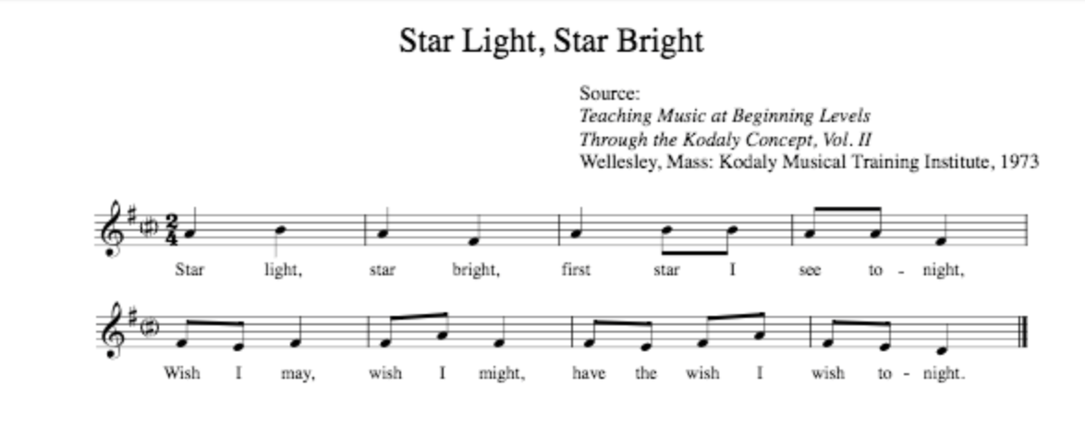

Objective:
Students will be able to sing song with accurate rhythm and pitch.
Students will be able to switch a song from G pentatonic to F.

Entry/Transition
- T invites students to pat a steady beats while T sing the song for the class.
- T “What is the song talking about?”
- T “What are some wishes you would make on a star?”
Transitions: “Now that we know what the songs about, it's your turn to learn the song itself!”
Melody Activity:
- Echo teach two bar phrases of the song, gradually moving to bigger pieces.
- Audiate melody (magic lips)
- Sing entire song as class.
- Review parts as necessary
- Pass out orff percussion instruments to students.
Percussion time!
- Mark the notes with stickers as needed for the song in its original key.
- T: Play the first two measures on xylophone.
- Take it one note at a time with the students and build up to playing the full two bars.
- Finish the entire song with the same approach as step 3, be sure to identify which parts are the same with the students! One you get to the second line, “hmm.. does this sound familiar?”
- Tell students that they now need to change it to F pentatonic (change the bars out to match the new scale).
- Attempt to play through the whole song in the new key. As hiccups occur, go back and review notes and/or rhythms.
- Perform song as a class.

Assessment: Teacher will observe students playing Star Light, Star Bright and keep a checklist of who was able to complete the transposition and who still needs more work.

Lesson 6
Materials: Wall Flowers
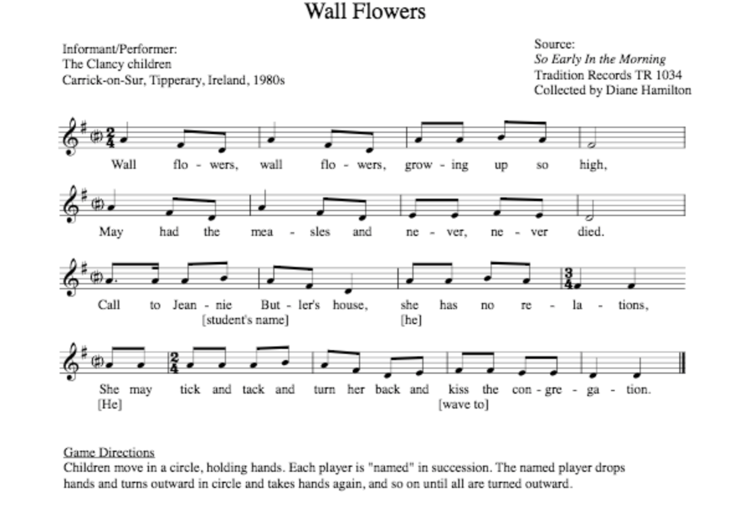
Objective:
Students will be able to sing song with accurate rhythm and pitch.
Students will display proficiency of musical concepts through participation in a game.
Entry/Transition
- “Hey everyone, today we’re going to be learning a new tune. Have you ever been really sick before? Well I hope you’re not today because we have singing to do! But this song talks about a disease that was really nasty way back in the day. It’s called measles, and it used to be a big problem for people but now we have a cure for it! This song is from when we didn’t have the cure though, so it’s about a sick girl.
Activity 1: Learn the Song
- T sing the song for the class.
- Echo each part of the song, gradually doing bigger pieces.
- Audiate
- Sing entire song as class.

Activity 2: Game Time
Game instructions: The children form a ring by joining hands. They all dance slowly round, singing the words. When the one child is named by the ring she turns round, so that her face is turned to the outside of the ring and her back inside. She still clasps hands with those on either side of her, and dances or walks round with them. This is continued until all the players have turned and are facing outwards. Meanwhile, the teacher will play the tune on the piano, and students will step to the tune in steady beat.

Lesson 7
Materials: Al Citron
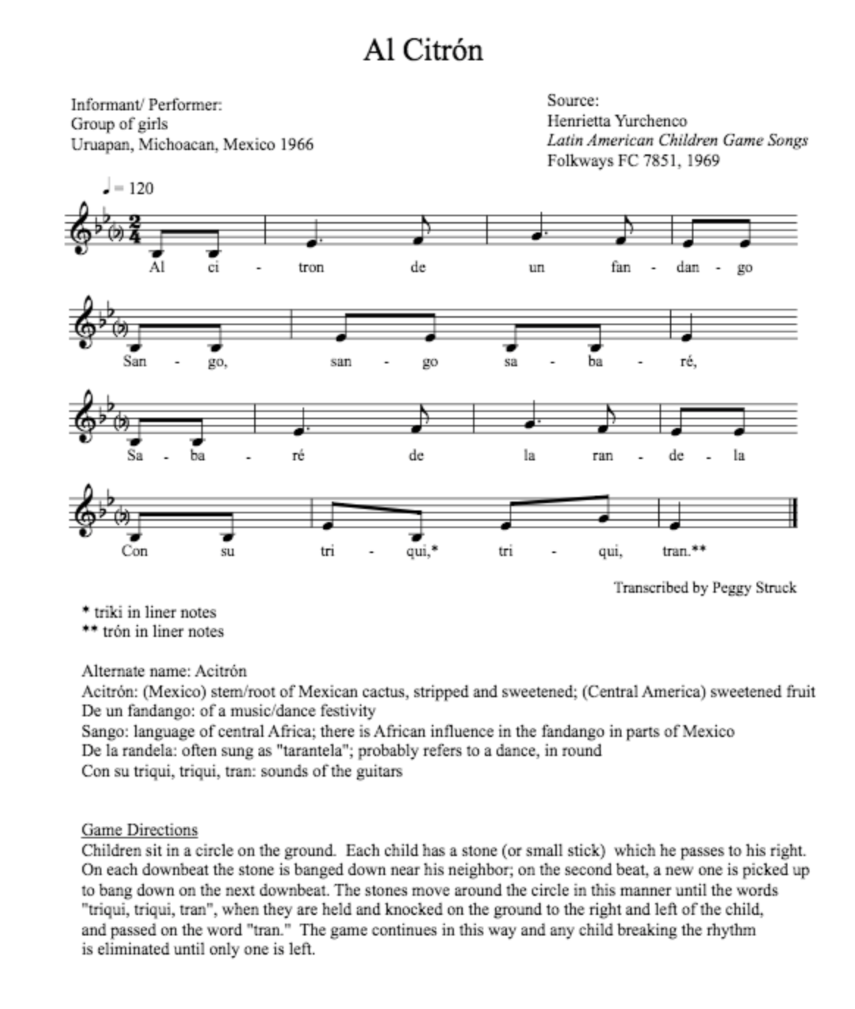

Objective:
Students will be able to sing song with accurate rhythm and pitch.
Students will display proficiency of musical concepts through participation in a game.
Activity 1: Learn The Song
- T sing the song for the class.
- Echo teach each part of the song two bars at a time, gradually doing bigger pieces.
- Audiate as a class.
- Sing entire song as class.

Activity 2: Game Time
Game Instructions: Pass the stone to the right (or left, as the video below shows) on the downbeats and pick up the stones on the in-between beats. On the penultimate measure, instead of releasing the stone, tap the stone to the right, tap in front, and then release it.

Video Example:
https://youtu.be/hH9sRz23WpE

Assessment: Classroom discourse will be observed by teacher and feedback will be given to correct errors.

Lesson 8

Standards Being Addressed:

​​MU:Pr5.1.3b Rehearse to refine technical accuracy, expressive qualities, and identified performance challenges.
MU:Cr1.1.3b Generate musical ideas (such as rhythms and melodies) within a given tonality and/or meter.

Objective: Students will be able to compose two measures of melody to a given rhythm.

Entry Activity
- “Good morning! Building off of our improvisation, we are going to begin to compose our own melodies and creating songs as a class”

Main Activity
- Students will break up into 4 groups, each group will have one xylophone with different color stickers on G, A, B, D, and E.
- Review Quarter and half notes and quarter rests.
- Have each group draw a random rhythm card with only quarter and half notes and quarter rests.
- Each group will then compose two measures using the colored keys to the rhythm they were given.
- As students are composing, teacher should walk around the room and assist as needed.
- Group will come back together and each group will play their melodies as one class song. (T take note of each melody so they can refer to it in the next lesson.)
Assessment: Students will make one coherent melody based on the given rhythms.

Lesson 9
Standards Being Addressed:

​​MU:Pr5.1.3b Rehearse to refine technical accuracy, expressive qualities, and identified performance challenges.
MU:Cr1.1.3b Generate musical ideas (such as rhythms and melodies) within a given tonality and/or meter.

Objective: Students will be able to compose four measures of melody to a given rhythm.

Entry Activity
- “Good morning! Go back to your groups from our last lesson, we are going to add onto our songs we began creating.”

Main Activity
- Students will break up into their four groups, each group will have one xylophone with different color stickers on G, A, B, D, and E.
- Review previous melodies that they created.
- Review eighth and sixteenth notes and dotted eighth notes.
- Have each group draw a random rhythm card with only these rhythms.
- Each group will then compose four measures using the colored keys to the new rhythm they were given along with body percussion.
- As students are composing, teacher should walk around the room and assist as needed.
- Group will come back together and each group will play their melodies as one class song. (T take note of each melody so they can refer to it in the next lesson.)
Assessment: Students will make one coherent melody based on the given rhythms.

Lesson 10
Standards Being Addressed:

​​MU:Pr5.1.3b Rehearse to refine technical accuracy, expressive qualities, and identified performance challenges.
MU:Cr1.1.3b Generate musical ideas (such as rhythms and melodies) within a given tonality and/or meter.

Objective: Students will be able to take a melody in G pentatonic and play it in F pentatonic instead.

Materials:

Entry Activity
- “Good morning! Go back to your groups from our last lesson, we are going to try changing the sound of our songs by changing our starting pitch.”

Main Activity
- Students will break up into their four groups, each group will have one xylophone with different color stickers on F, G, A, C, and D.
- Review previous melodies that they created.
- Students will then be told to change their melodies to F pentatonic instead.
- Give students time to think about what this means, ask questions, and practice it.
- Each group will perform their melodies in F pentatonic.
Assessment: Students will make one coherent melody based on the given rhythms.

Elementary Unit 6 Songs and Analyses

Song Title: Great Big House in New Orleans

Tone Set: F G A C D/ DRM SL (Transposed from D to F for Lesson)

Range: F4 – D5

Rhythm Set: Two eighth notes, quarter notes

Form: ABAB

Melody: F pentatonic, solidifies the adding of re, and before that, do.

Rhythm: 2 eighth notes review, and usage of ties.

Other: Other verses can begin talk about strophic forms and repeated ideas. F and G pentatonic focus.

Other info: Sail Away book, Page #17, Song #19

Song Title: Here Comes a Bluebird

Tone Set: G A B D E/ DRM SL (Transposed from D to G for lesson)

Range: G4 – E5

Rhythm Set: Two eighth notes, quarter notes, quarter rest

Form: ABA’B

Melody: G pentatonic, stepwise motion (mi, re, do) adds in re and do pitches.

Rhythm: Multiple eighth notes in a row, review of quarter rests.

Other: Has game associated, could be used with dalcroze/eurythmics style lesson. F and G pentatonic unit.

Other Info: Kodaly Center Online

Song Title: Knock the Cymbals

Tone Set: F G A C D/ DRM SL (Transposed from D to F for lesson)

Range: F4 – D5

Rhythm Set: Dotted Eighth and Sixteenth, Two eighth notes, quarter notes, half notes

Form: ABAC

Melody: F pentatonic, outlining tonic major triads, skip further than minor 3rd (perfect fourth)

Rhythm: Introduction/Review of Dotted Eighth and Sixteenth rhythm, review half note

Other: Has associated game to play for movement, F and G pentatonic Unit

Other Info: Kodaly Center Online

Song Title: Star Light, Star Bright

Tone Set: G A B D E/ DRM SL (transposed from D to G for lesson)

Range: G4 – E5

Rhythm Set: two eighths, quarter notes

Form: AABB

Melody: Review mi, sol, la, addition of re and do.

Rhythm: Consecutive eighth notes on changing pitches, review two eighths

Other: F and G pentatonic

Other Info: Kodaly Center Online

Song Title: Wall Flowers

Tone Set: G A B D E/ DRM SL (transposed from D to G for lesson)

Range: G4 – E5

Rhythm Set: Dotted Eighth and Sixteenth, two eighth notes, quarter notes, half notes

Form: AA’BB’

Melody: Outlining tonic triad, stepwise motion to do (review intro. of re and do)

Rhythm: Introduction/Review of Dotted Eighth and Sixteenth notes, continuous eighths.

Other: Game included with song, F and G pentatonic Unit

Other Info: Kodaly Center Online

Song Title: Al Citron (World Music Song)

Tone Set: C F G A/ S DRM (Transposed from Eb to F for lesson)

Range: C4 – A4

Rhythm Set: Dotted Quarter and one eighth, two eighths, quarter note

Form: AA’

Melody: Low sol, review re and do

Rhythm: Introduce dotted quarter and eighth note, review two eighths

Other: F and G Pentatonic, Game comes with song. Mexican origins

Other Info: Kodaly Center Online

