Dakota Cavanaugh
9/20/18
Elementary Unit 6 Songs and Analyses

Song Title: Great Big House in New Orleans

Tone Set: F G A C D/ DRM SL (Transposed from D to F for Lesson)

Range: F4 – D5

Rhythm Set: Two eighth notes, quarter notes

Form: ABAB

Melody: F pentatonic, solidifies the adding of re, and before that, do.

Rhythm: 2 eighth notes review, and usage of ties.

Other: Other verses can begin talk about strophic forms and repeated ideas. F and G pentatonic focus.

Other info: Sail Away book, Page #17, Song #19

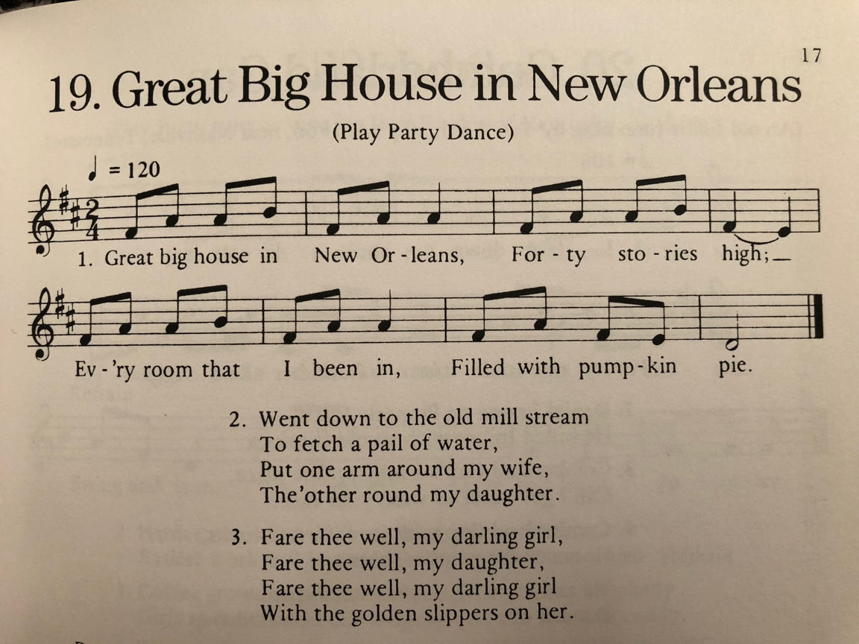

Song Title: Here Comes a Bluebird

Tone Set: G A B D E/ DRM SL (Transposed from D to G for lesson)

Range: G4 – E5

Rhythm Set: Two eighth notes, quarter notes, quarter rest

Form: ABA’B

Melody: G pentatonic, stepwise motion (mi, re, do) adds in re and do pitches.

Rhythm: Multiple eighth notes in a row, review of quarter rests.

Other: Has game associated, could be used with dalcroze/eurythmics style lesson. F and G pentatonic unit.

Other Info: Kodaly Center Online

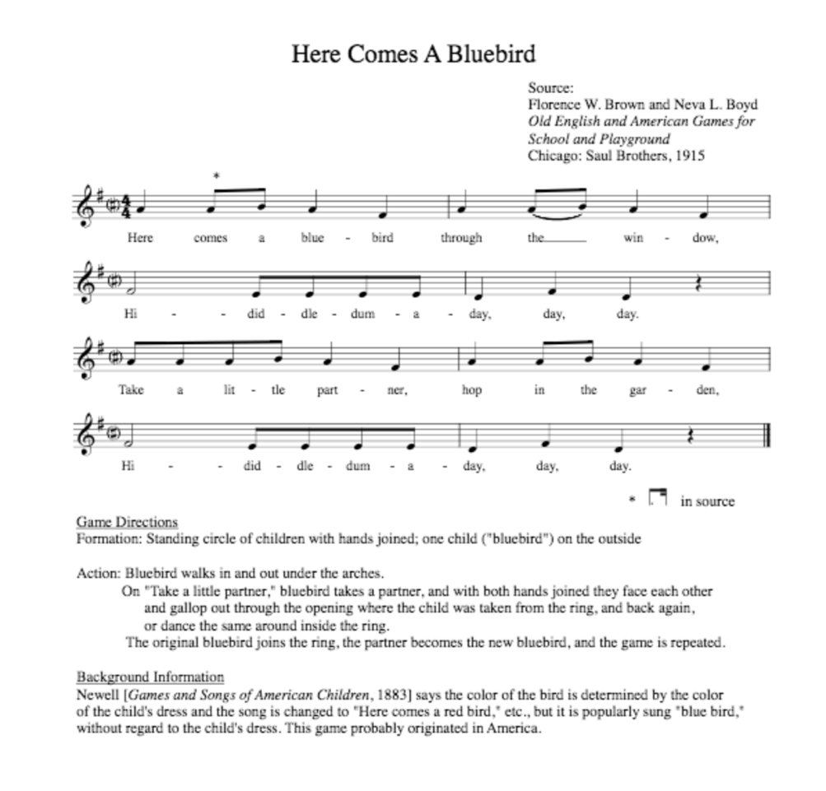

Song Title: Knock the Cymbals

Tone Set: F G A C D/ DRM SL (Transposed from D to F for lesson)

Range: F4 – D5

Rhythm Set: Dotted Eighth and Sixteenth, Two eighth notes, quarter notes, half notes

Form: ABAC

Melody: F pentatonic, outlining tonic major triads, skip further than minor 3rd (perfect fourth)

Rhythm: Introduction/Review of Dotted Eighth and Sixteenth rhythm, review half note

Other: Has associated game to play for movement, F and G pentatonic Unit

Other Info: Kodaly Center Online
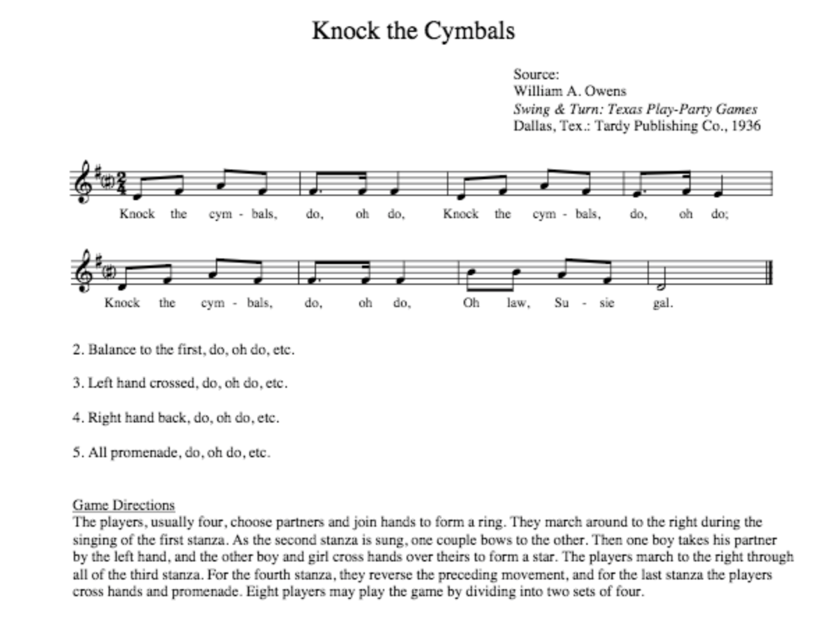

Song Title: Star Light, Star Bright

Tone Set: G A B D E/ DRM SL (transposed from D to G for lesson)

Range: G4 – E5

Rhythm Set: two eighths, quarter notes

Form: AABB

Melody: Review mi, sol, la, addition of re and do.

Rhythm: Consecutive eighth notes on changing pitches, review two eighths

Other: F and G pentatonic

Other Info: Kodaly Center Online

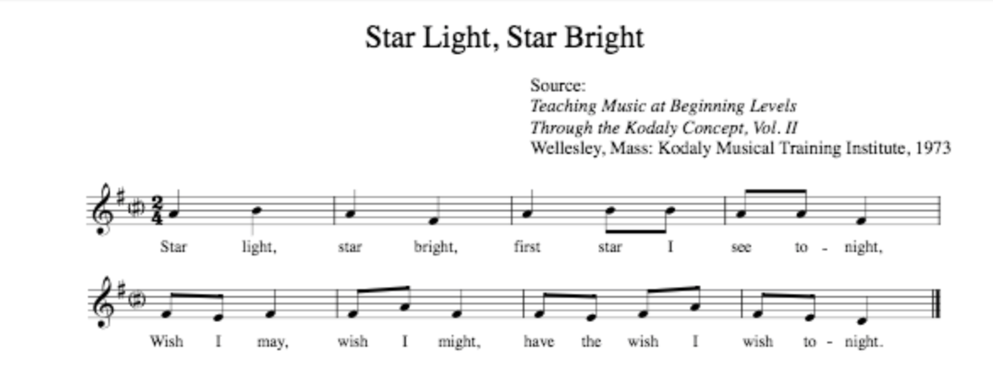

Song Title: Wall Flowers

Tone Set: G A B D E/ DRM SL (transposed from D to G for lesson)

Range: G4 – E5

Rhythm Set: Dotted Eighth and Sixteenth, two eighth notes, quarter notes, half notes

Form: AA’BB’

Melody: Outlining tonic triad, stepwise motion to do (review intro. of re and do)

Rhythm: Introduction/Review of Dotted Eighth and Sixteenth notes, continuous eighths.

Other: Game included with song, F and G pentatonic Unit

Other Info: Kodaly Center Online

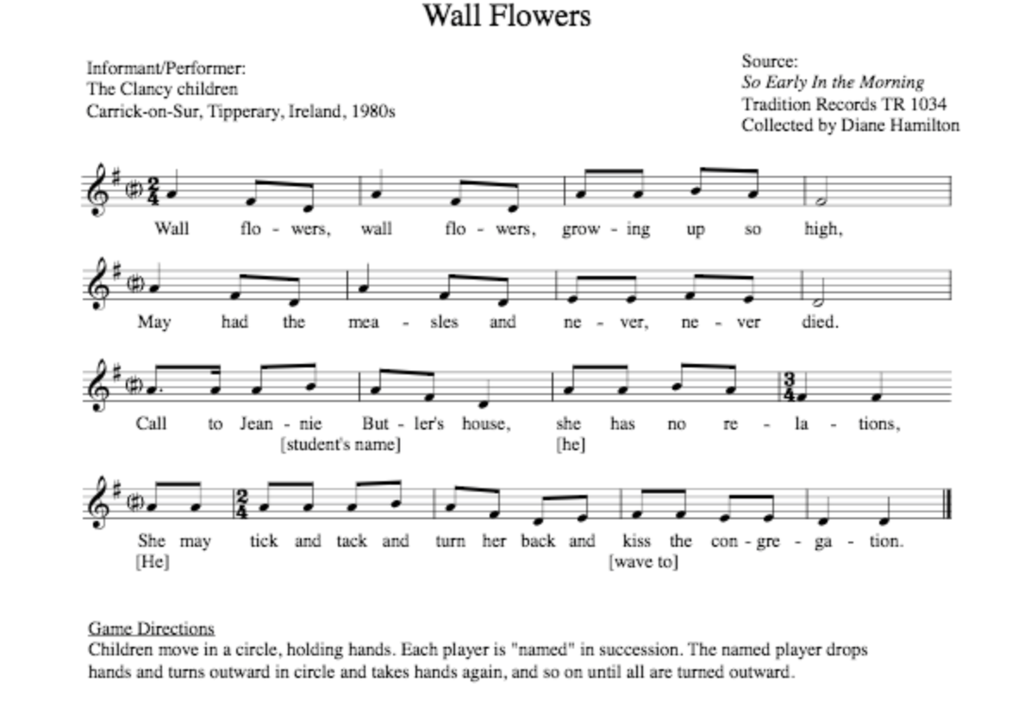

Song Title: Al Citron (World Music Song)

Tone Set: C F G A/ S DRM (Transposed from Eb to F for lesson)

Range: C4 – A4

Rhythm Set: Dotted Quarter and one eighth, two eighths, quarter note

Form: AA’

Melody: Low sol, review re and do

Rhythm: Introduce dotted quarter and eighth note, review two eighths

Other: F and G Pentatonic, Game comes with song. Mexican origins

Other Info: Kodaly Center Online

