Peer Teaching #1 Lesson Plan

Teacher Name: Mr. Cavanaugh

Standards Being Addressed: MU:Pr6.1.1a With limited guidance, perform music for a specific purpose with expression.
Materials of Instruction: Black Snake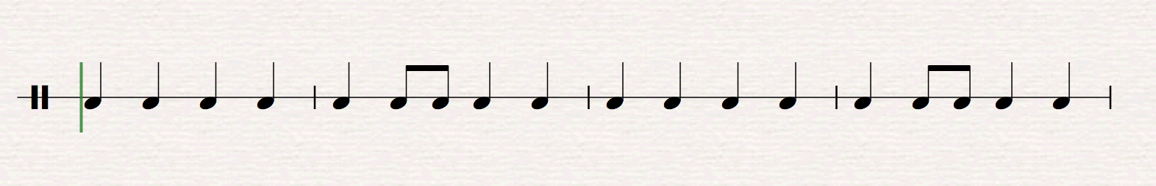
Black snake black snake,
Where are you hiding?
Black snake black snake,
Where are you hiding?
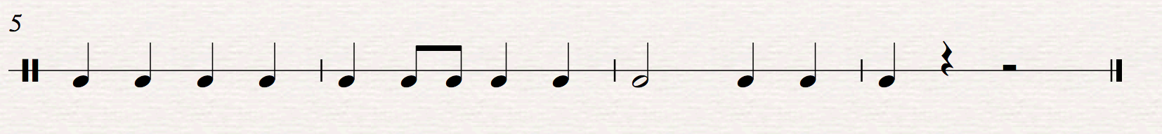
Black snake black snake,
Where are you hiding?
Don’t you bite me!

Body Percussion

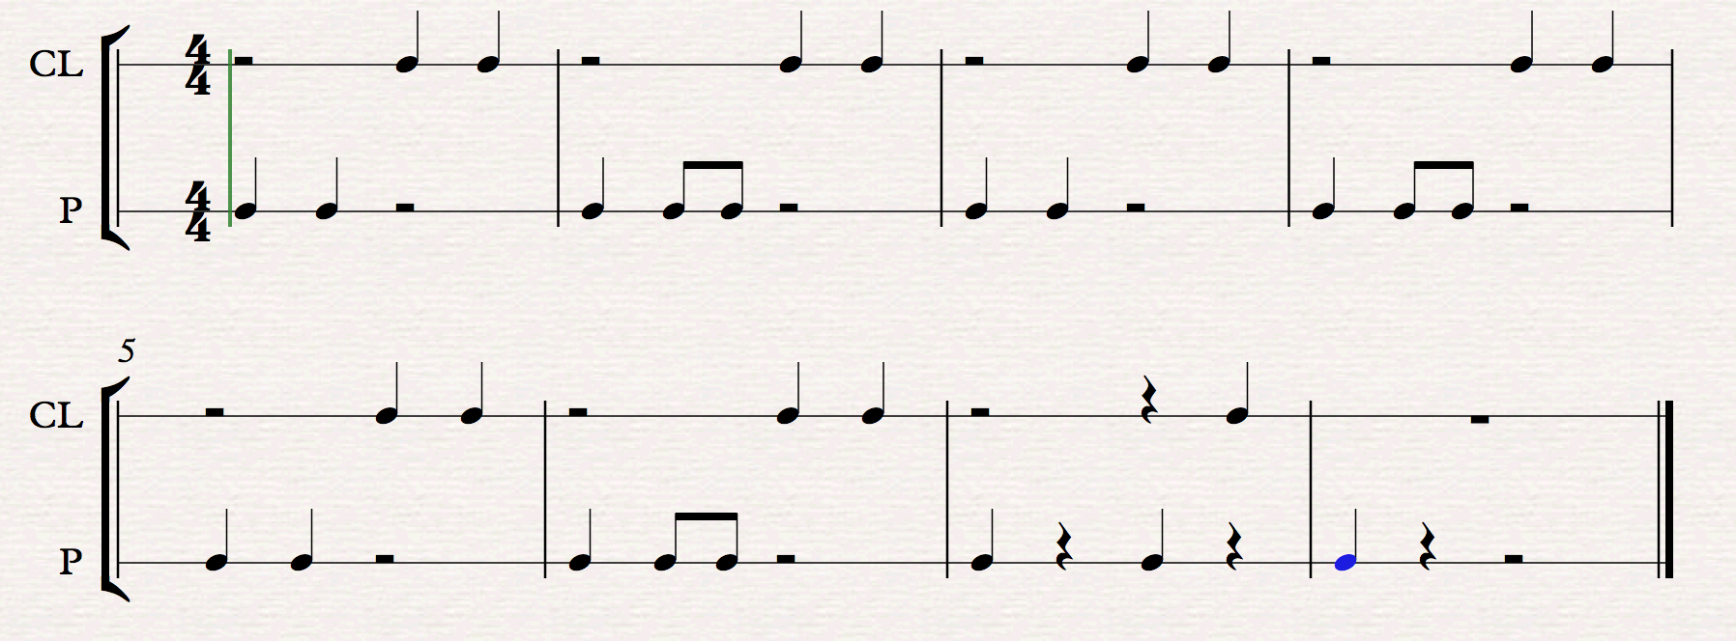

Phrase 1-3 (say once, then repeat 2 times)

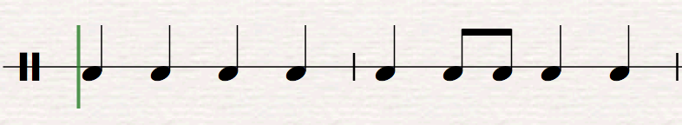
Black snake black snake where are you hi – ding?

Phrase 4
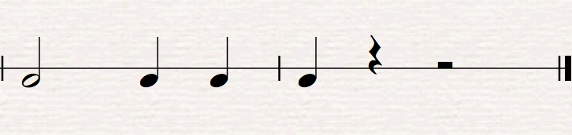
Don’t you bite me

Lesson Sequence:
Entry Activity/Transition:
- Introduce the song by chanting it while playing beat on a hand drum. Ask the students what the song was about, then have them share with their shoulder partners quietly. (15 seconds)

Activity #1: Students in 1st grade will recite a rhythmic text, Black Snake, with accurate beat and rhythm in duple meter.
- Recite the poem for the students, emphasizing the difference between measures 1-6, and measure 7-8.
  - Have the students lightly pat the rhythm on their lap while you chant and have the students echo throughout the rest of this sequence. This will help them keep a steady beat.
- T: “Alright now, I’m going to say a line, and when I point to you guys, I want you to repeat it for me.”
  - Teacher: “Black snake black snake”
    - Students: “Black snake black snake” (assess and repeat until students can recite confidently.)
- Echo the second bar with students, repeating as needed for comprehension. Don’t move on without correctness.
  - Teacher: “Where are you hi-ding?”
    - Students: “Where are you hi-ding?”
- Once students can recite both lines, recite them together through the echo method.
  - T: “Black snake black snake, where are you hi-ding?”
    - Ss: “Black snake black snake, where are you hi-ding?”
- T: recites poem “Now, can someone raise their hand and tell me how many times I repeated that line?” Ss: “3 times.” T: Great job! Now let’s try saying that first line three times in a row.
  - T: “Black snake black snake, where are you hiding?” X3
    - Ss: “Black snake black snake, where are you hiding?” X3
- Learn the last line through fill in the blank.
  - T: Don’t bite___?
    - Ss: Me!
- Recite the last line while continuing the tapping and hand signs.
  - T: Don’t bite me!
    - Ss: Don’t bite me!
- Use fill in the blank again to review each line
  - T: Black snake black ______
    - Ss: Snake
  - T: Where are you______
    - Ss: Hiding
  - (Repeat a and b 2 more times)
  - T: Don’t bite ______
    - Ss: Me!
- Use an extended echo and alternate lines with the students
  - T: Black snake black snake
    - Ss: Where are you hiding
  - T: Black snake black snake
    - Ss: Where are you hiding
  - T: Black snake black snake
    - Ss: Where are you hiding
  - T: Don’t bite _____
    - Ss: Me!
- T: “Now, I’m going to say the poem all together, and I want you guys to think through the rhyme in your head without saying anything.” recite poem
- T: “This time I want you to use your magic lips, and pretend say the words while I say the poem. 1, 2, ready, go” Quit the tapping so the students can internalize the pulse.
- Have students recite the whole chant, with teacher assistance, then without. Review as mistakes are made.
Closure: Good job learning our cool new rhyme, and over the next couple days we will add other things to make our rhyme even cooler! Maybe some body-percussion, actions, or instruments.

Assessment: Can students recite the poem “black snake” with accurate beat and rhythm? (teacher observation)

Activity #2 Objective (Peer Teaching #2): Students in 1st grade will perform body percussion to accompany “Black Snake” with steady beat and accurate rhythm in 4/4 meter.

- T will start by reviewing the rhyme with the students, speaking the rhyme and having them join in as they feel comfortable. Ss will pat quarter notes on their lap while saying the poem.
- T will have Ss cease clapping. T: Now watch what I do, and join in once you figure out the pattern!” T will pat/clap steady quarter notes, alternating beat 1 and 2 as patting, and beat 3 and 4 as clapping, as seen in the first measure of the body percussion. Continue repeating until students figure it out, and then join in.
- T: “Watch me, and pay close attention, I’m going to change something!” T will then add in the 8th notes patting on beat three of every even numbered measure (2, 4, etc.) T: “Now, I’m going to do that again and I want you guys to try and join in with me!” T should repeat as necessary until all students catch on.
- T: Stops patting/clapping. “Now, can anyone raise their hand and tell me who our story is about? Ss: “A snake!” T: “Great! And what was our snake doing?” Ss: “He was hiding!” T: “Good job! And at the very end, what do we tell the snake not to do?” Ss: “Bite us.” T: “Perfect! Now, we’re going to learn the last bit of body percussion to go with the part where we tell the snake not to bite us.”
- T will demonstrate the last phrase 2 times in a row. *Put your hands out on the rests, which gives a silent action to help keep the rhythm in rests. T: “Alright now I want you guys to join me! 1, 2, ready, go!” Repeat as needed for student comprehension.
- T: “Watch closely, I’m going to do the last line one more time and add something new.” T recites last line, but add snake action to the rests in the very last measure. T: “Before we try it all together, I want you guys to show me your best snake action like what I just did!” Allow students to try their own snake action.
- T: “Now let’s put it all together! How many times do we ask the snake where its hiding? Ss: “3” T: “Perfect! Let’s do that part three times, then add the last line that we just learned. Watch me first, then join in on the second time around and keep going so we can practice it.” All join in on BP and rhyme, slow down if needed, then gradually speed up to regular pace.
- T will assess the rhyme and BP while the students continue to do the body percussion.

Assessment: T will watch Ss for mistakes in the body percussion parts, and keep going until they can do it without mistakes. T will also assess the rhyme when it is added back in.

Transition/Closure: T: Great job today!! You guys did an awesome job at performing a whole song! The patting and clapping we did today is called body percussion. We are going to be doing some more of it the next times I see you all! So, go home and show mom and dad, and come back ready to learn more!

